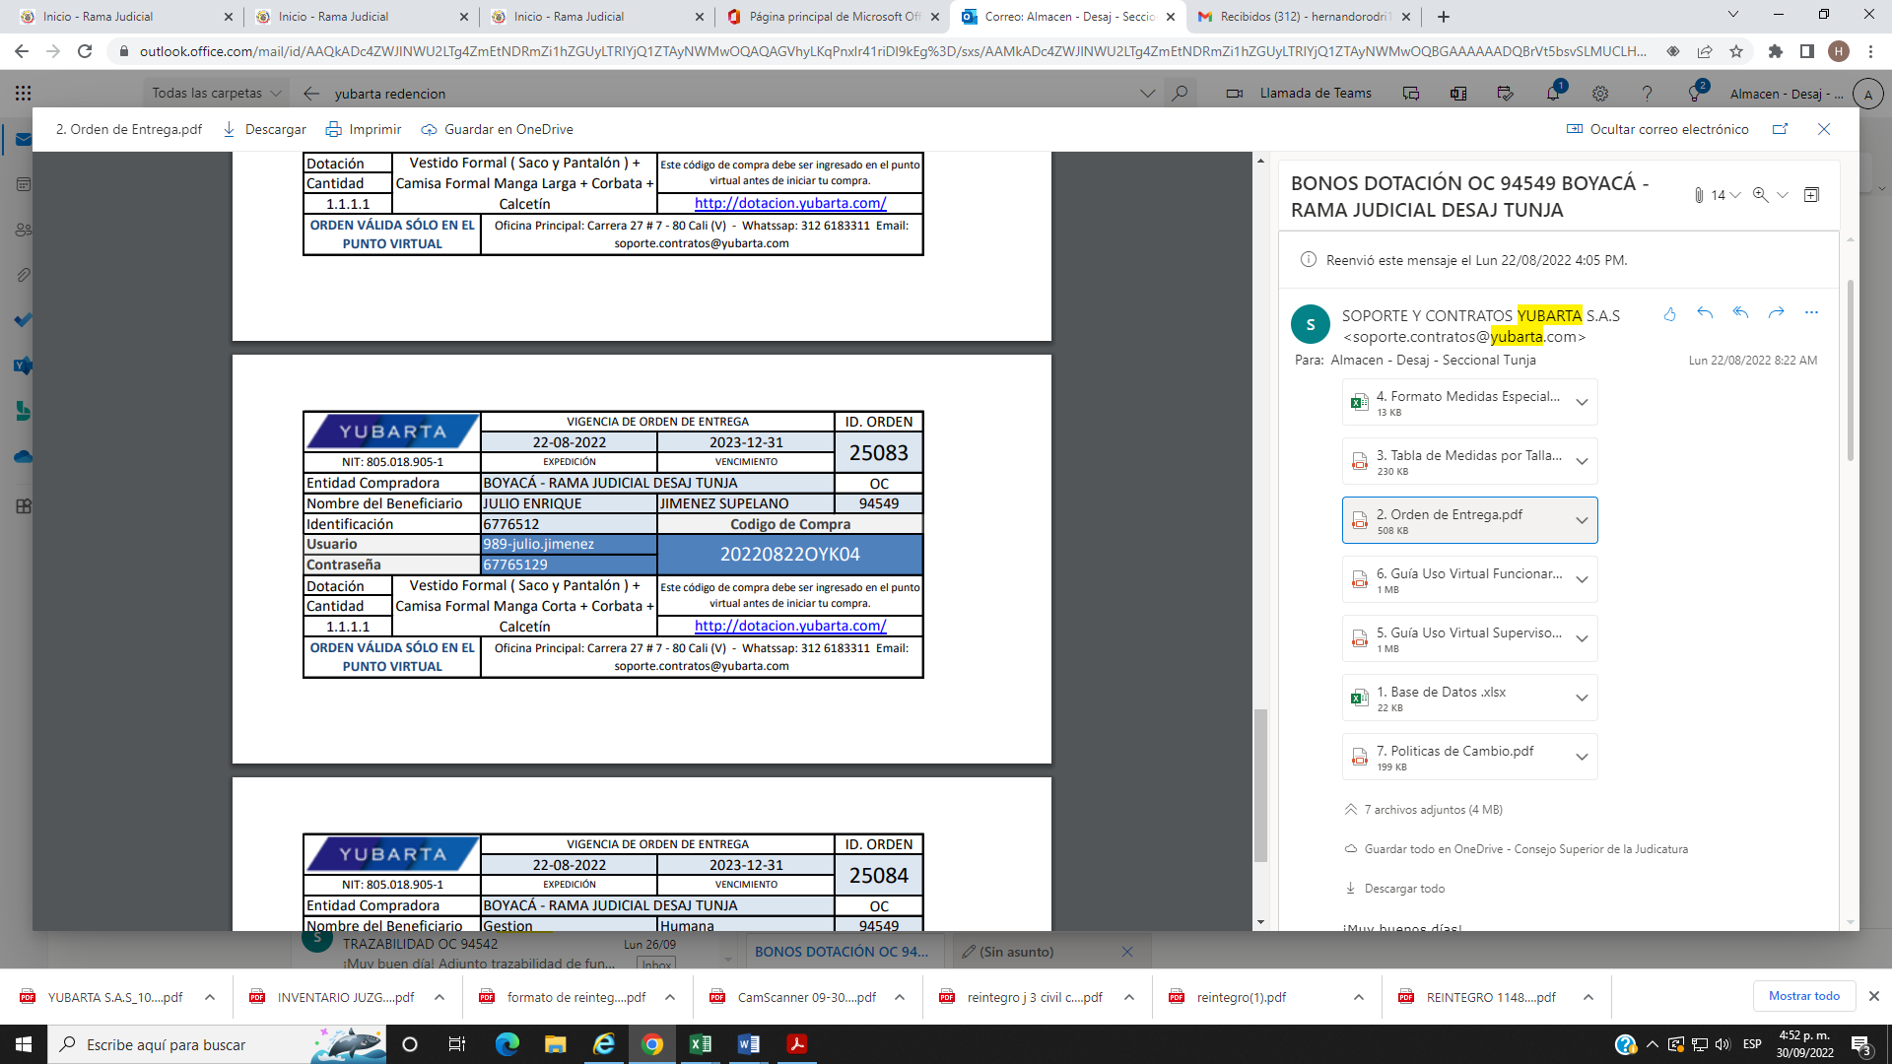

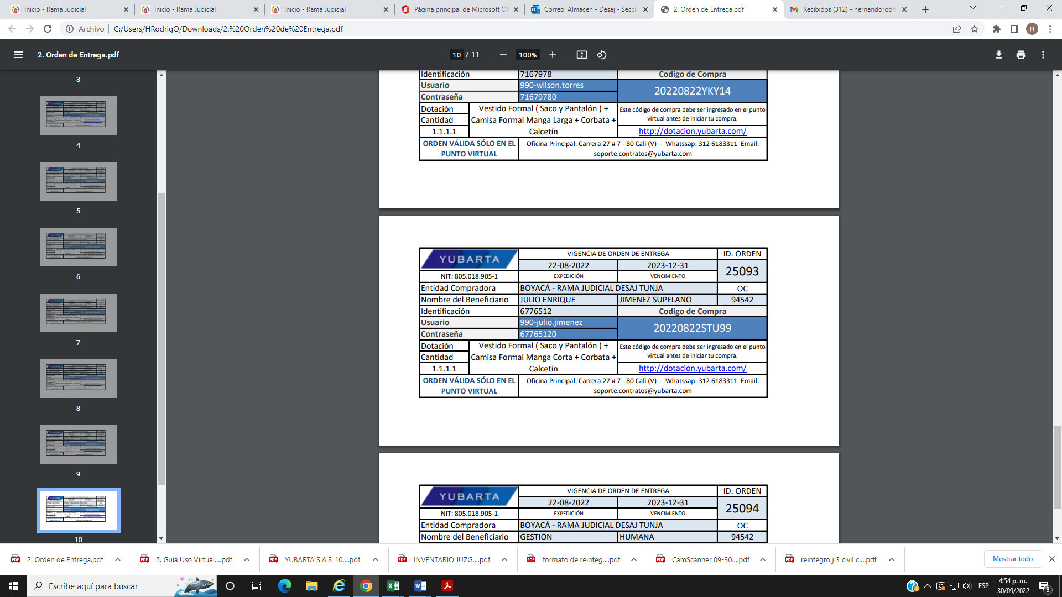

|  |  |  |  |  |  |  |  |  |
| --- | --- | --- | --- | --- | --- | --- | --- | --- |
| 74015 | JULIO ENRIQUE JIMENEZ | 6776512 | Calcetín para Calzado de Calle - Caballero | Modelo - 1 | Negro | 1 | 10-12 |  |
| 74015 | Camisa Formal Manga Larga - Caballero | Modelo - 5 | Gris TO | 1 | XL | 2 |
| 74015 | Corbata - Caballero | Modelo - 20733 | Blanco Corbarta 20733 | 1 | U |  |
| 74015 | Vestido Formal ( Pantalón ) - Caballero | Modelo - 1 | Gris Ceniza (Sastre Formal) | 1 | 34 | 1 |
| 74015 | Vestido Formal ( Saco ) - Caballero | Modelo - 4 | Gris Ceniza (Sastre Formal) | 1 | 44 | 1 |