**PSEDC-Segmento1 - Lote 1 - Evento 177290**

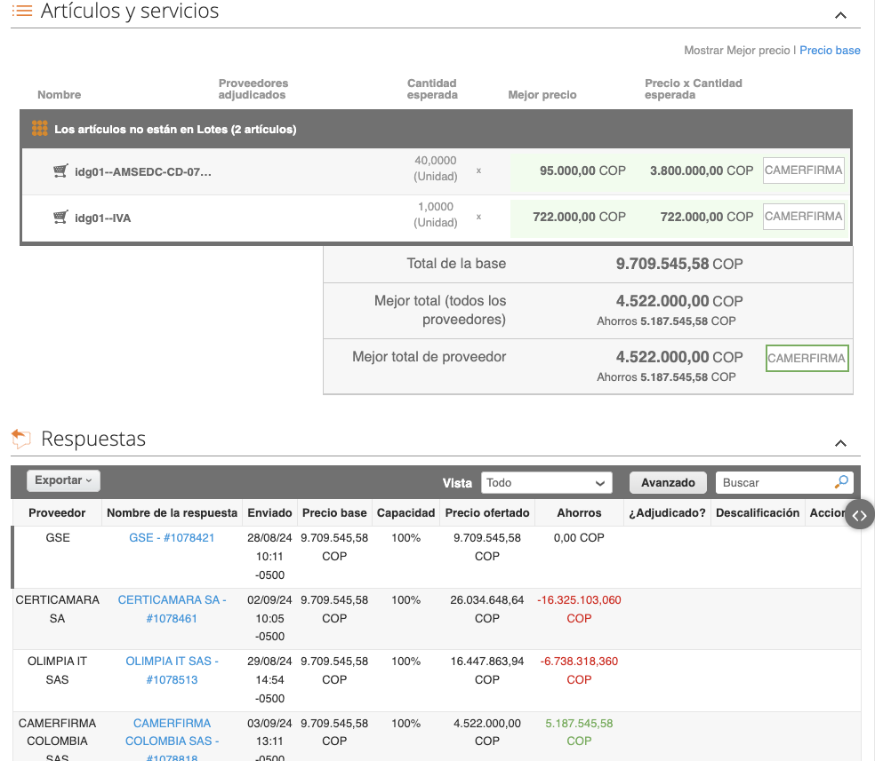

**CAMERFIRMA COLOMBIA SAS**

